**GitLab & Jira Integration**

**Table of Contents**

|  |  |
| --- | --- |
| Topics | Page Number |
| Installing Jira, Login into Admin, creating the dashboard and user story creation | 01 -02 |
| Installing gitlab(AWS console), Login as Admin, Adding external url, Restarting gitlab | 03 -04 |
| Creating users in gitlab, SSH keys generation, Creating project and committing the code changes | 04-08 |
| Integrating jira in gitlab and creating service template(gitlab), Jiraservice setup(Jira) | 09-13 |
| Production setup | 14-16 |
| Recommendations | 16 |

**Installing Jira in local system**

Download the Zip file and startup the batch file in foreground and used custom port 8888 for Jira.

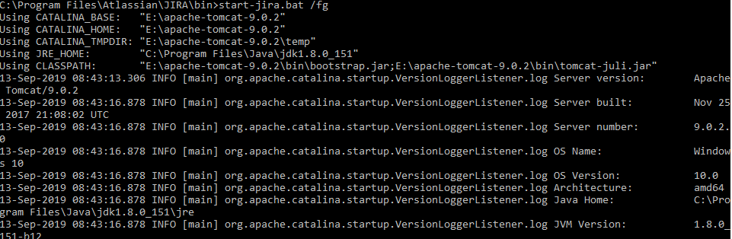

**Login into Jira**

[**http://192.168.220.1:8888/secure/Dashboard.jspa**](http://192.168.220.1:8888/secure/Dashboard.jspa)

create the Administrator account in Jira

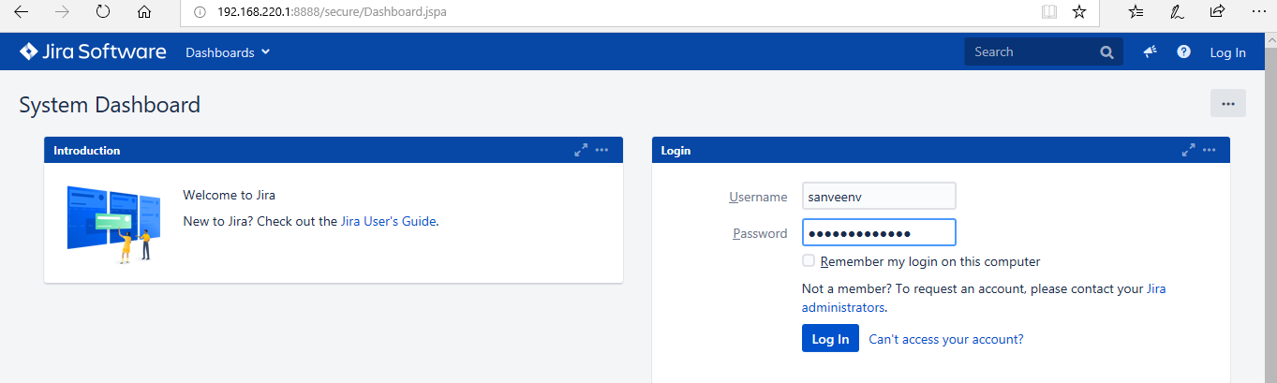

Created the Sprint and the user story which matches with Manulife user story.

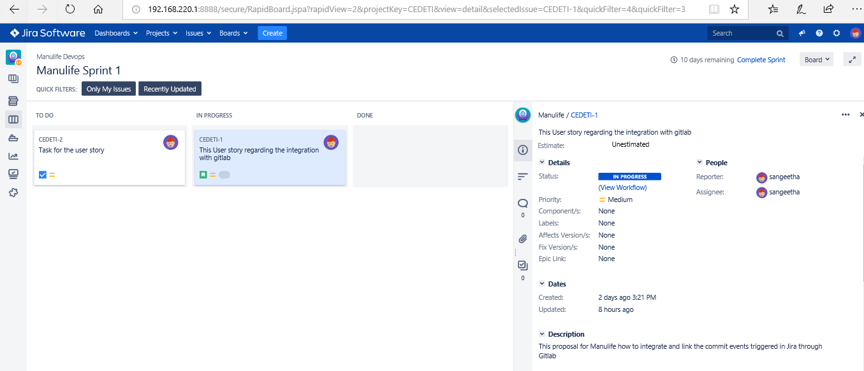

**GitLab Installation**

Taken AWS EC2 instance (Ubuntu) for installing Gitlab with Admin features. Install Gitlab in ubuntu.

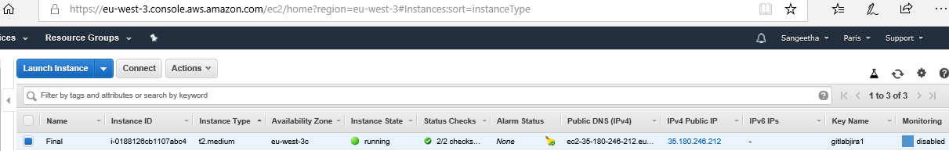

**Connecting the Ubuntu instance through gitbash**

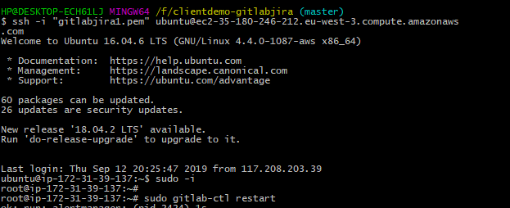

**Starting/Stopping the gitlab instance, below is the command.**

sudo gitlab-ctl stop

sudo gitlab-ctl start

For restarting the gitlab sudo gitlab-ctl restart

We need to do the following settings in /etc/gitlab/gitlab.rb

Make a changes by adding external url and add the local ip in the monitoring_whitelist

cat gitlab.rb

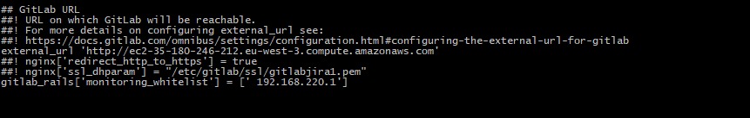

**Once make a changes , pleas reconfigure the gitlab to make in effective**

* **sudo gitlab-ctl reconfigure**

Then Login into Gitlab URL as mentioned in external_url and login as Administrator

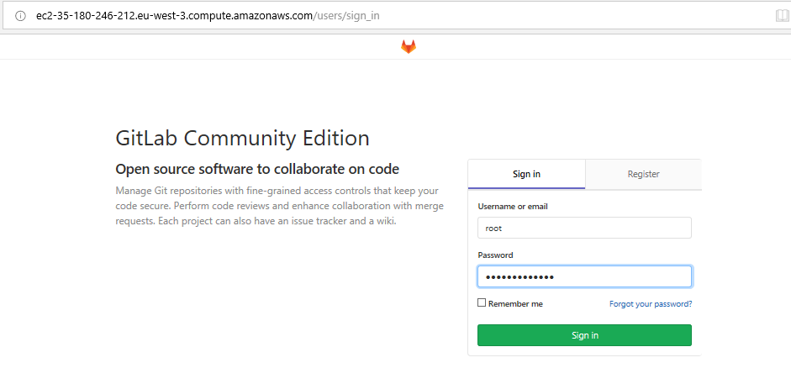

Then created members in setting under Admin access and assign to the specific group

1. created users as sangeetha and Dhanvannthvp

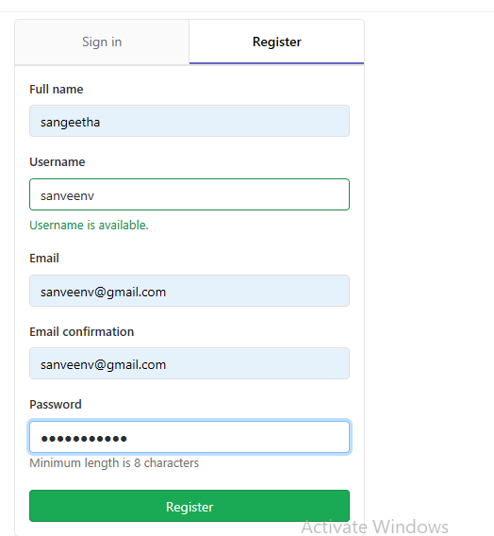

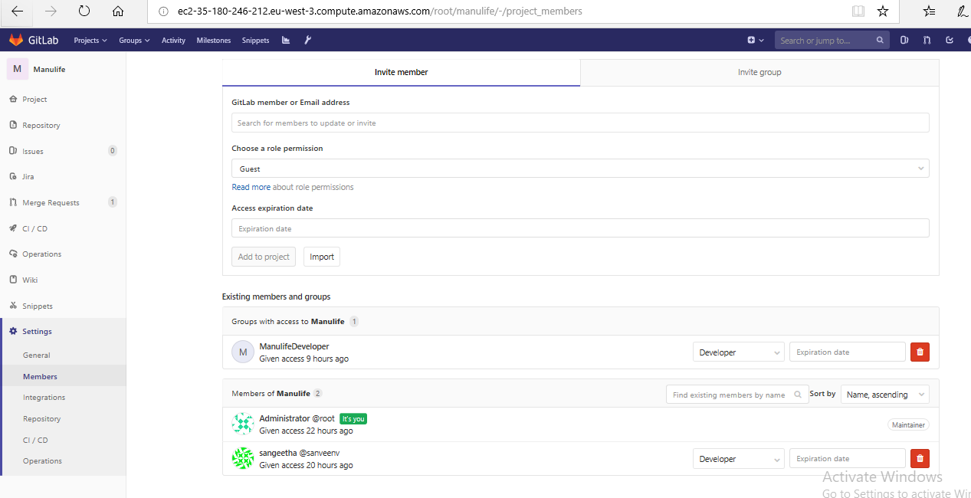

one more user in gitlab

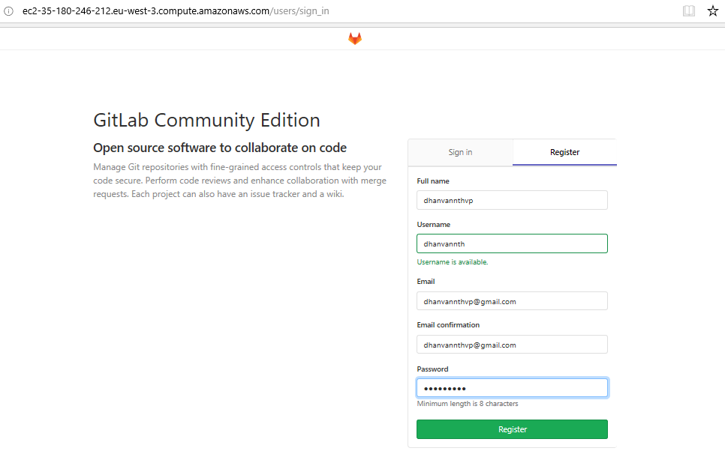

And then add the user dhanvannth in the specific group

**Creating local repository and configuring changes**

Do the configuration in gitlab with username,email in local repository

**Git init** – will create the local repository.

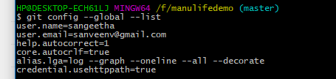

Clone your gitlab repository in local repository

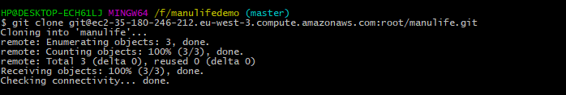

**SSH Keys Generation**

Generate the SSH keys to connect between your local system with Gitlab

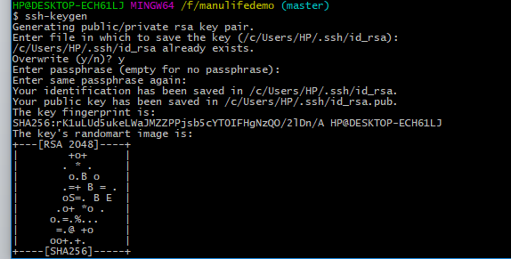

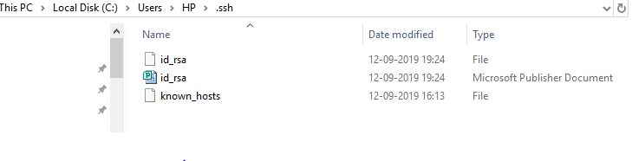

Copy the Public Key and Paste it under SSH keys. So created the connection between local system and gitlab

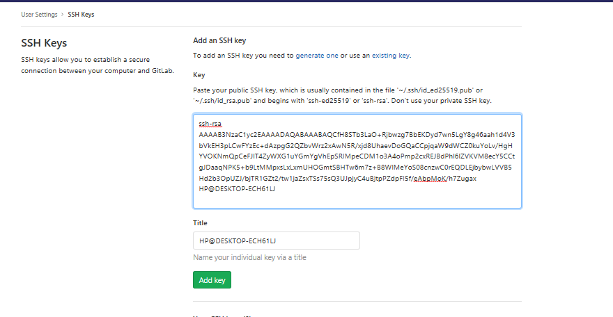

**Adding Jira local ip in whitelist**

And also please add the Jira local IP in gitlab network to accept it.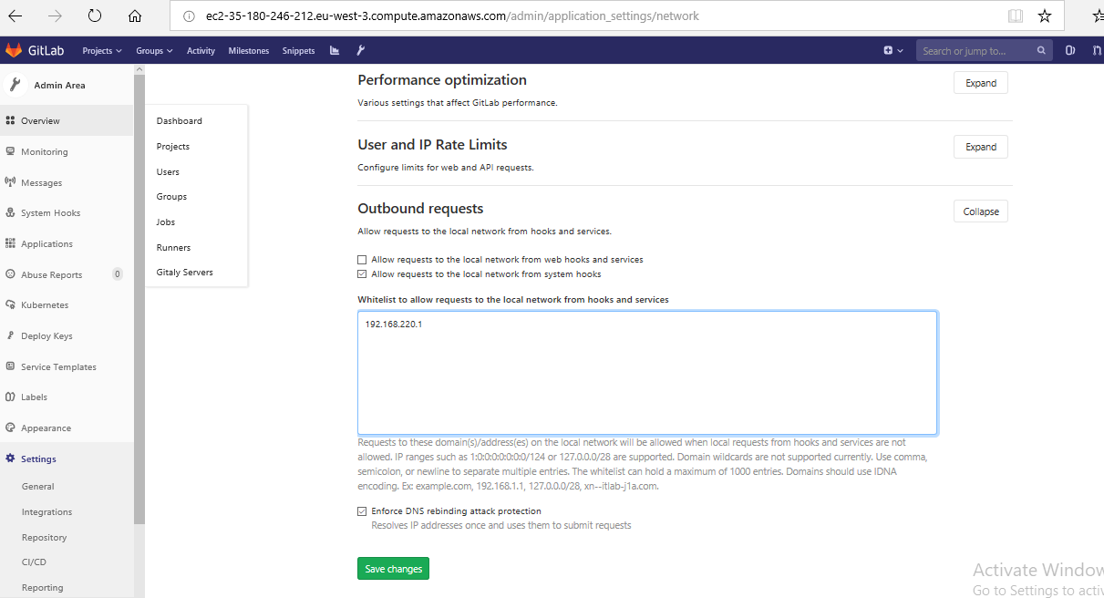

Created one Manulife project in gitlab and push your code from local repository

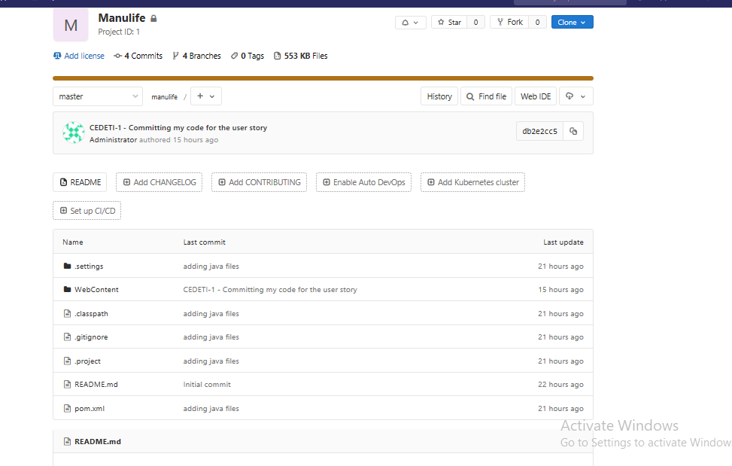

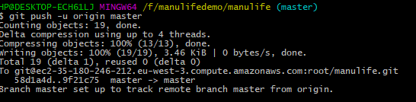

**Integrating jira in Gitlab**

And also Admin is having the rights to create Jira service template in Gitlab

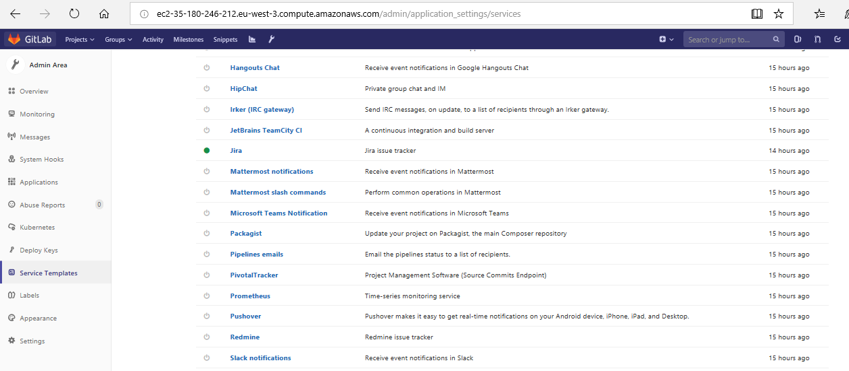

And filling up with all required details from Jira

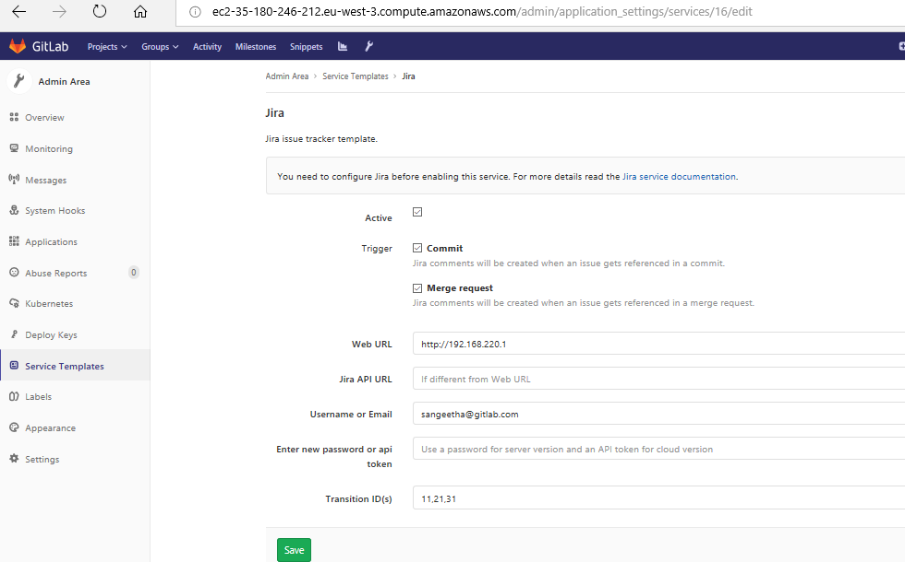

**Jira service setup**

Below is the screenshot to get API token, user name, Transition ID(s) from Jira end which required for service template in gitlab

**To set API tokens,**

Click create and manage API tokens, generate the API token for your account. AxAuDW8INA5ae78diRjR39B7 is my jira API token.

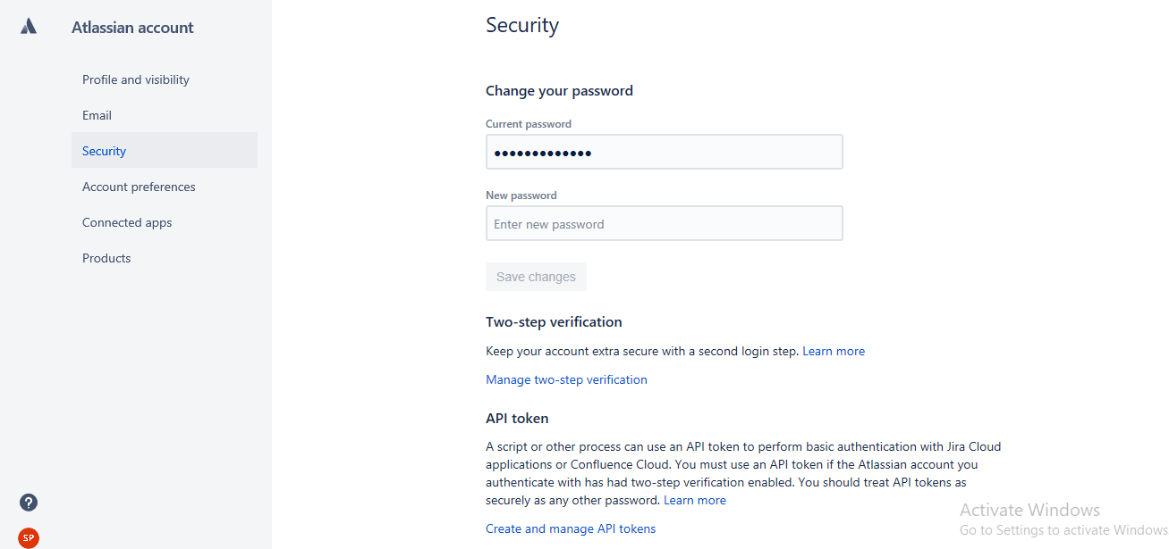

Go to Admin access, click workflows for the specific project, able to find the Transition ids for the user story. Copy the number and provide in service template under Transition ids in Gitlab

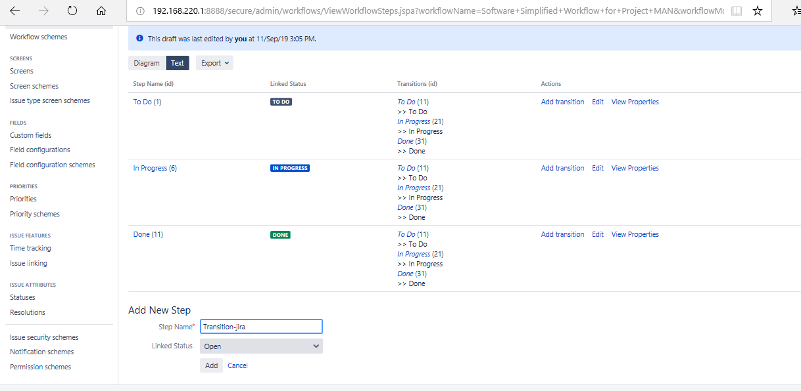

**User creation and Granting permission**

Create a user and assign to the group under Admin previleges

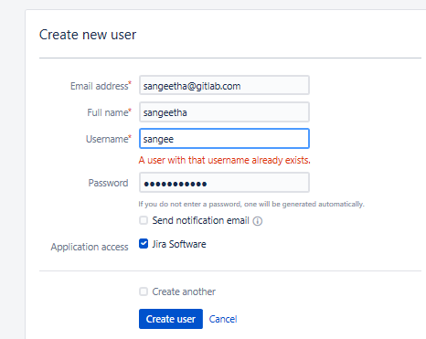

Step2: Creating group and add the user to the group



Click selected issues->Permission Schemes

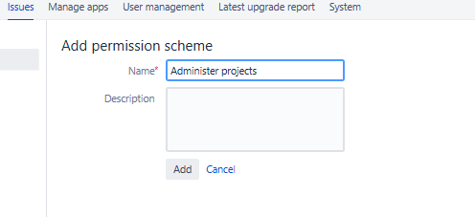

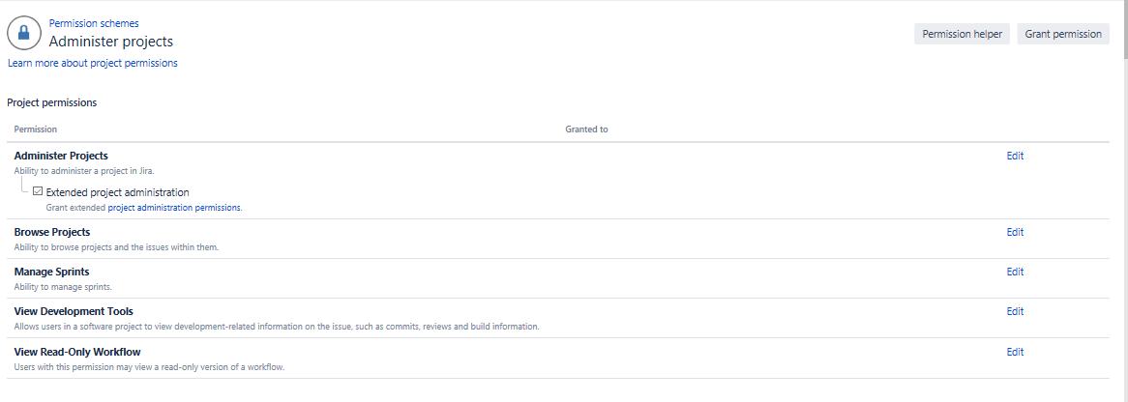

Grant permissions

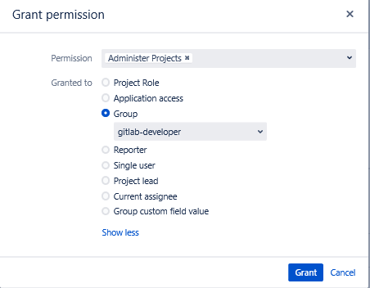

**Both settings done in Gitlab and Jira**.

Now commit the message in gitlab and it will be reflected under comment section in jira.

**Configuring Jira issue Tracker in Gitlab – Specific format**

When GitLab project has Jira issue tracker configured and enabled, mentioning Jira issue in GitLab will automatically add a comment in Jira issue with the link back to GitLab. This means that in comments in merge requests and commits referencing an issue, e.g., PROJECT-7, will add a comment in Jira issue in the format:

USER mentioned this issue in RESOURCE_NAME of [PROJECT_NAME|LINK_TO_COMMENT]:

ENTITY_TITLE

* USER A user that mentioned the issue. This is the link to the user profile in GitLab.
* LINK_TO_THE_COMMENT Link to the origin of mention with a name of the entity where Jira issue was mentioned.
* RESOURCE_NAME Kind of resource which referenced the issue. Can be a commit or merge request.
* PROJECT_NAME GitLab project name.
* ENTITY_TITLE Merge request title or commit message first line.

# Proposal for Solution - Production

**GitLab Configuration**

Mention a Jira issue ID in a commit message or merge requests in GitLab, the GitLab hyperlinks will be reflected in the comment section to the Jira issue about the comment author, and a link to the commit/merge in GitLab.

Go to Settings -> Integrations ->Project Services -> Jira Issue Tracker

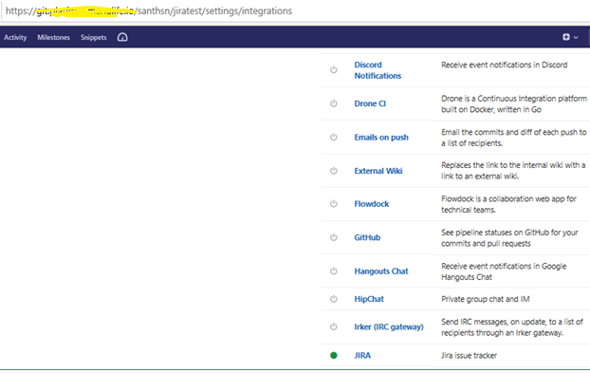

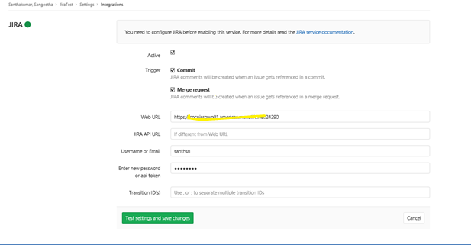

Activate the Jira issue tracker by providing Jira Web URL, Username and Password, Jira service will be activated after the testing got successful.



Do the changes on your file and commit User story with Description.



It will populate under comment section in Jira User story

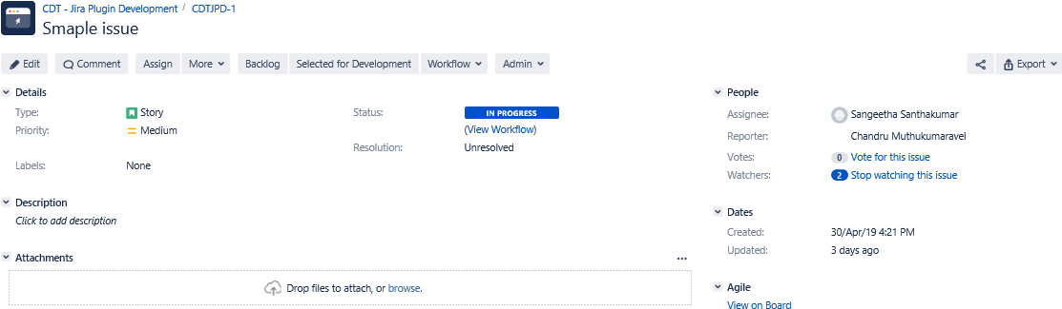

**Recommendations:**

**Try to install jira and Gitlab in same OS**

**Please check whether you are able to get connection from gitlab to Jira**

**In Production Environmnt, User in Active directory and able to login both jira nd Gitlab. So it is easy to establish connection between Gitlab and Jira.**

**Just Try and Let me know!!!!**